**Access control list (ACL)**

**To verify the default ACL of the file or directory**

**getfacl /file or directory**

**getfacl mobile**

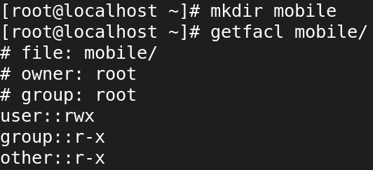

**Before that we want to create a directory :**

**mkdir /mobile**

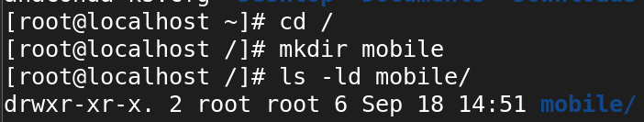

**Now,**

**Setting ACL on a directory for a specific user:**

**setfacl -m u:username:7 /directory setfacl -m u:arunagiri:7 /mobile**

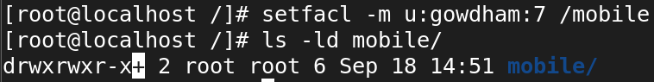

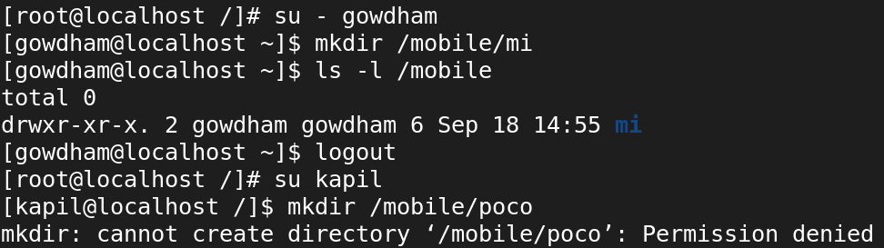

**Setting ACL on a file for a specific user:**

**setfacl -m u:username:6 /file**

**setfacl -m u:arunagiri:6/dog**

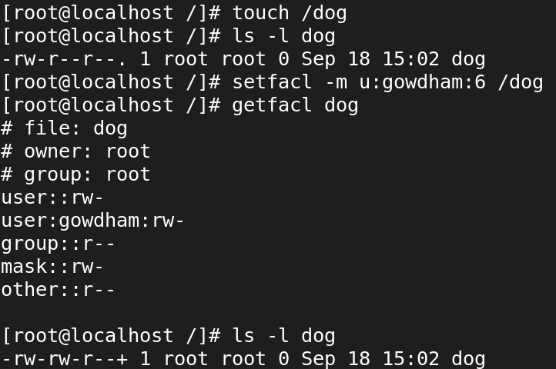

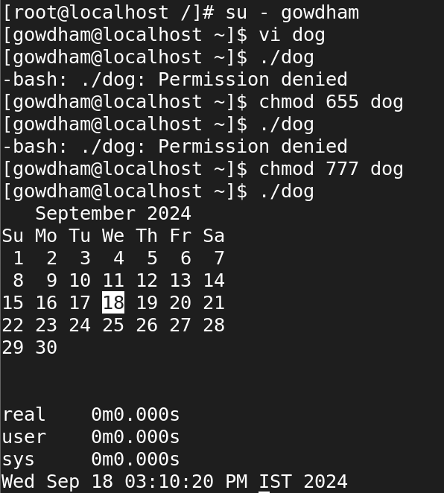

**To remove ACL on a file for a specific user**

**setfacl -x u:username /secure**

**setfacl -x u:username /mobile**

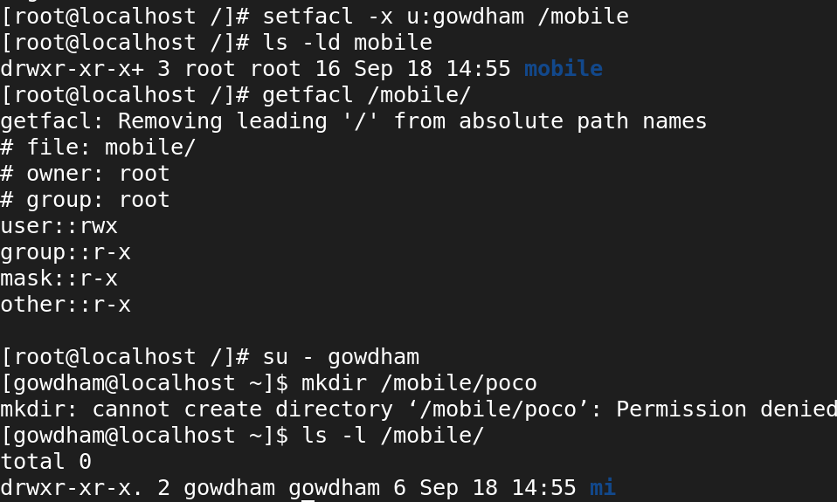

**To set ACL on a file for a specific group**

**setfacl -m g:groupname:rwx filename**

**setfacl -m g::7 filename**

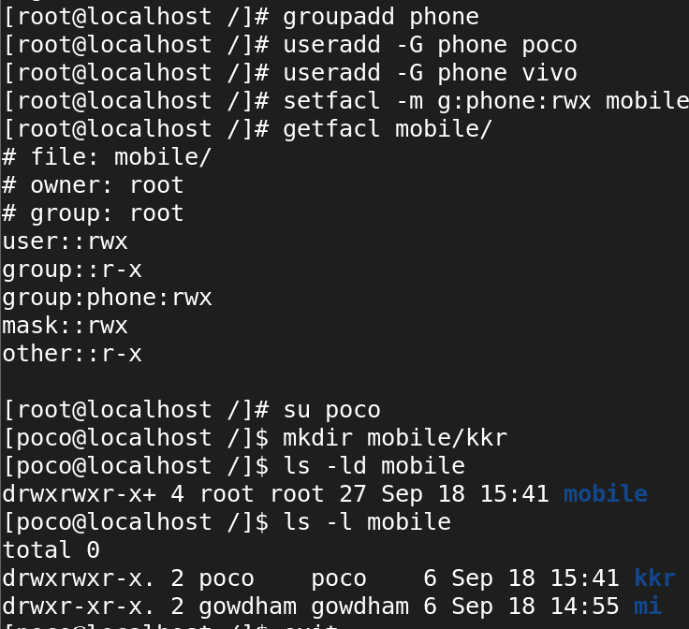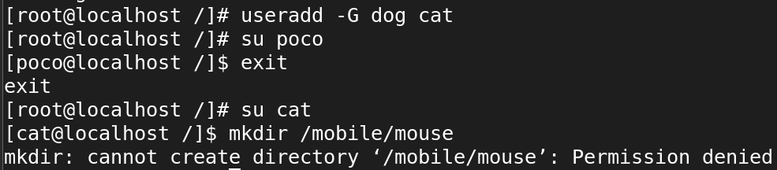

**To remove ACL on a file for a specific group**

**setfacl -x g:username /secure**

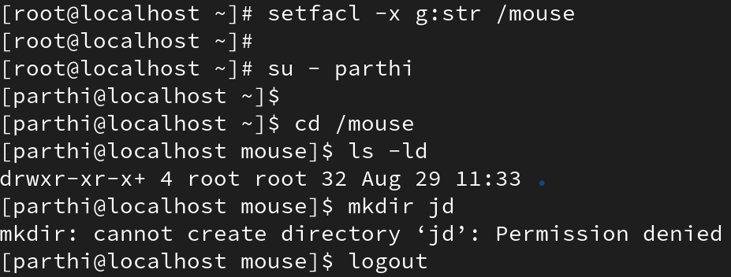

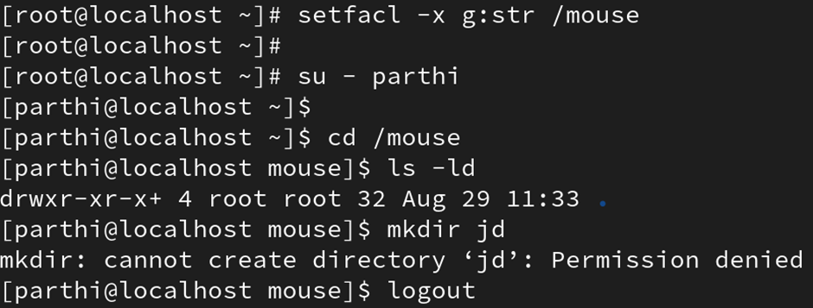

**To remove all ACL**

**setfacl -b file/directory**



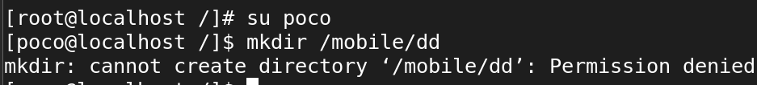

**To retrieve and display Access Control Lists (ACLs) for files and directories:**

**getfacl -R /mobile**

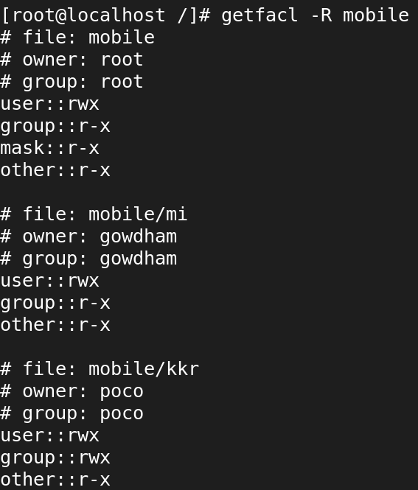

**To create a directory in the root directory / and make ensure that any files/directory created inside the directory having a default permissions of 700 permission using ACL:**

**mkdir /usb**

**chmod 700 /usb**

**setfacl -m d:u::7,d:g::0,d:o::0 /usb**

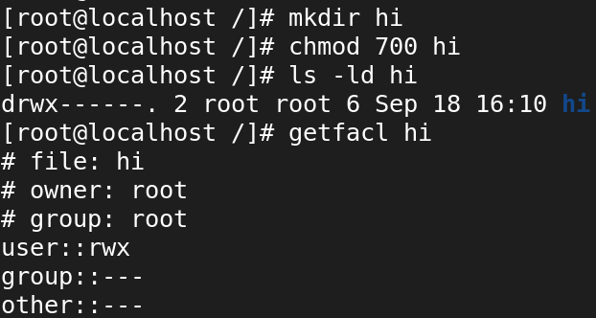

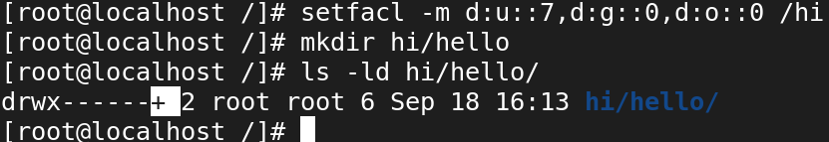

**removing all ACL from file/directory**

**To remove all ACL**

**# setfacl -b file/directory**

